**Sprint 2 - Accuracy Design Document**

**November 24, 2020**

1. **Executive Summary** 
   1. Project Overview
   2. Purpose and Scope of this Specification
2. **Product/Service Description** 
   1. Product Context
   2. User Characteristics
   3. Assumptions
   4. Constraints
   5. Dependencies
3. **Requirements 4**
   1. Functional Requirements
   2. Security
      1. *Protection*
      2. *Authorization and Authentication*
   3. Portability
4. **Requirements Confirmation/Stakeholder sign-off**
5. **System Design** 
   1. Algorithm
   2. System Flow
   3. Software
   4. Hardware
   5. Test Plan
   6. Task List/Gantt Chart
   7. Staffing Plan

1. Executive Summary

1. ***Project Overview***

The objective of this project is to complete the intended Robot project with clear indications on sprints, accuracy and agility. The intended audience for this project is for CS104.

* 1. ***Purpose and Scope of this Specification***

The purpose of this specification is to allow people to use the robot where it is intended to be like on smooth surfaces. The audience for our product could be anything from children to adults, students and professors.

**In scope**

* The product is only meant to smooth surfaces

**Out of Scope**

* The product is not meant to be on uneven or loose surfaces such as carpets and sand

1. Product/Service Description
2. ***Product Context***

The product relates to the other two spirits like the agility test and endurance test . The product is not independent or self-contained because it needs to be programmed/coded and it needs to be tested. The product is completely useless on its own unless it is controlled by an outside source or another device. Yes the product does interact with a variety of systems. The systems include interacting with the Sphero app for coding and connecting to the app via bluetooth to control the robot.

1. ***User Characteristics***
   1. Student
   2. Classmates
   3. Professor
   4. Professionals
   5. ***Assumptions***

The availability of the Robot, We also assume that each user is competent in the field of software engineering, and there is also an assumption that syphero would be the operating system that an individual uses in order to make sure that robot meets the desired requirements for this project. In addition, the robot should work as intended, and there is an assumption that each group understands the necessary software to complete the robotics project. Finally, we as a group assumed that the physical conditions of Robot would be less taxing on the project. For example, for this portion of the project accuracy, Ryan had tested the robot in his garage. The garage was a smaller room than the room at Monmouth and the wear and tear of his garage included cracks and breaks in the floor.

* 1. ***Constraints***
* Syphero having an update that interferes with how the robot operates
* Measurement requirements may change
* Syphero requires the app be downloaded
* Physical locations the design needs to abide by may change
* One Member had access to the Robot
* Our group works part time/full time jobs
* Covid-19 Limited our opportunities to meet up with fellow group members
* The surfaces that the robot was tested was not smooth surface (it was in a cracked on concrete)
  1. ***Dependencies***
* Robot must follow the correct path or it will not succeed towards the intended path/goal
* Code must be established before project may begin
* The project is dependent on the robot following the correct course

1. Requirements

The requirements involved in the accuracy portion had been given to us through professor Eckert outlined in the software development project. The requirements were that our robot had to successfully run the figure eight course five times.The robot will start and finish in the square provided. Upon finishing, the robot will speak ‘I am the winner’ and flash multicolored lights for 5 seconds.

**Priority Definitions**

The following definitions are intended as a guideline to prioritize requirements.

* Priority 1 - The robot must successfully run the figure eight course 5 times.
* Priority 2 - The robot must stay within the path provided
* Priority 3 - The robot will start and finish in the square provided
* Priority 4 - The robot upon finishing will speak “ I am the winner” and flash multicolored lights for 5 seconds

***Functional Requirements***

In the example below, the requirement numbering has a scheme - BR_LR_0## (BR for Business Requirement, LR for Labor Relations). For small projects simply BR-## would suffice. Keep in mind that if no prefix is used, the traceability matrix may be difficult to create (e.g., no differentiation between '02' as a business requirement vs. a test case)

The following table is an example format for requirements. Choose whatever format works best for your project.

For Example:

|  |  |  |  |  |  |
| --- | --- | --- | --- | --- | --- |
| **Req#** | **Requirement** | **Comments** | **Priority** | **Date Rvwd** | **SME Reviewed / Approved** |
| Acc_1 | Starts in square |  | Low | 11/22 | R/A  R/A  R/A |
| Acc_2 | Run “Figure 8” five times |  | High | 11/22 | R/A  R/A  R/A |
| Acc_3 | Speaks “I am the winner” |  | Low | 11/22 | R/A  R/A  R/A |
| Acc_4 | Flashes multi-colored lights |  | Low | 11/22 | R/A  R/A  R/A |
| Acc_5 | Finishes in original square |  | High | 11/22 | R/A  R/A  R/A |

* 1. ***Security***
     1. **Protection**
        1. Collaboration on github
        2. Logging in and out of sphero
        3. Quality assurance tests
  2. **Authorization and Authentication**
* This would be only allowing one member to access the robot. The single member with access to the robot will be able to input code needed for the navigation of the obstacle course. You can have access to the product via a username and password upon use.
  1. ***Portability***
* Percentage of components with host-dependent code;
* Percentage of code that is host dependent;
* Use of a proven portable language;
* Use of a particular compiler or language subset;
* Use of a particular operating system;
* The need for environment-independence - the product must operate the same regardless of operating systems, networks, development or production environments.

1. Requirements Confirmation/Stakeholder sign-off

|  |  |  |
| --- | --- | --- |
| **Meeting Date** | **Attendees (name and role)** | **Comments** |
| 11/20 | Ryan (tester) | All requirements reviewed and approved |
| 11/20 | Evan (organizer/design/scribe) | All requirements reviewed and approved |
| 11/20 | Daniel (coder/scribe) | All requirements reviewed and approved |

1. System Design

This section will provide all details concerning the technical design, staffing, coding, and testing the system

1. ***Algorithm***
   * Robot must start in the square provided
   * Robot must complete the figure eight loop five times
   * Robot must finish in the square provided
   * Robot upon finishing must speak “I am the winner”
   * Robot must flash multicolored lights for five seconds
   1. ***System Flow***

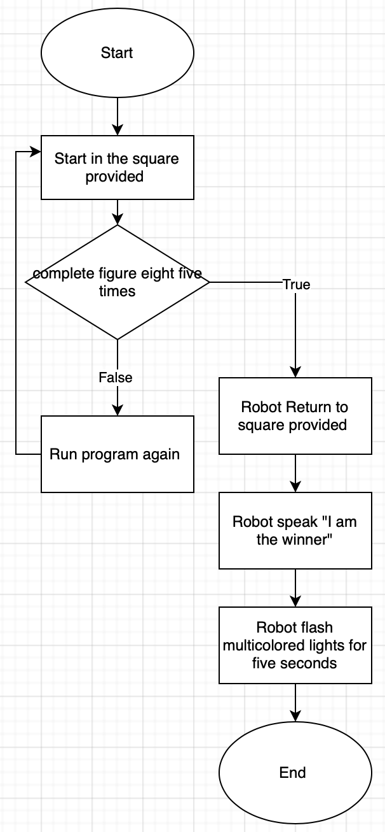

Develop a flowchart (and show here) that accurately depicts how your software application will act to fulfill the algorithm

* 1. ***Software***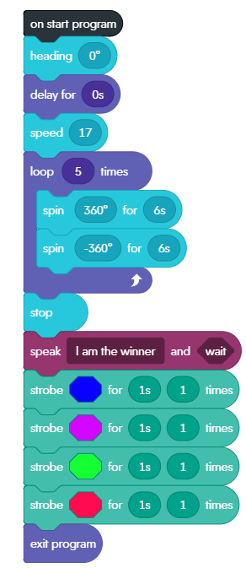

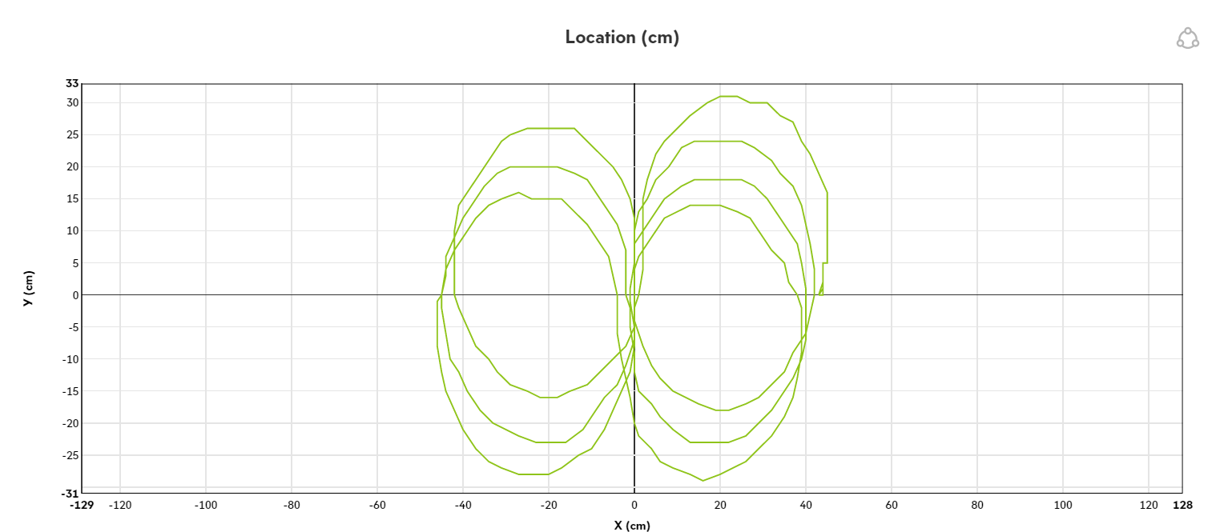

1. ***Test Plan***

|  |  |  |  |  |  |
| --- | --- | --- | --- | --- | --- |
| **Reason for Test Case** | **Test Date** | **Expected Output** | **Observed Output** | **Staff Name** | **Pass/Fail** |
| Figure 8 | 11/22 | Will make a figure 8 | Made a figure 8 | Ryan | Pass |
| Goes around objects | 11/22 | Will not hit obstacles | Hit obstacles | Ryan | Fail |
| Goes around objects | 11/22 | Will not hit obstacles | Hit obstacles | Ryan | Fail |
| Goes around objects | 11/23 | Will not hit obstacles | Hit obstacles | Ryan | Fail |
| Goes around objects | 11/23 | Will not hit obstacles | Went around obstacles | Ryan | Pass |
| Stops in square | 11/23 | Will stop in starting square | Did not stop in starting square | Ryan | Fail |
| Stops in square | 11/23 | Will stop in starting square | Did not stop in starting square | Ryan | Fail |
| Stops in square | 11/23 | Will stop in starting square | Did not stop in starting square | Ryan | Fail |
| Stops in square | 11/24 | Will stop in starting square | Did not stop in starting square | Ryan | Fail |
| Stops in square | 11/24 | Will stop in starting square | Stopped in starting square | Ryan | Pass |
| Speaks “I am the winner” | 11/24 | Will speak “I am the winner” | Spoke “I am the winner” | Ryan | Pass |
| Multi-colored Lights | 11/24 | Will light up with multiple colors | Lit up with multiple colors | Ryan | Pass |

* 1. ***Task List/Gantt Chart***

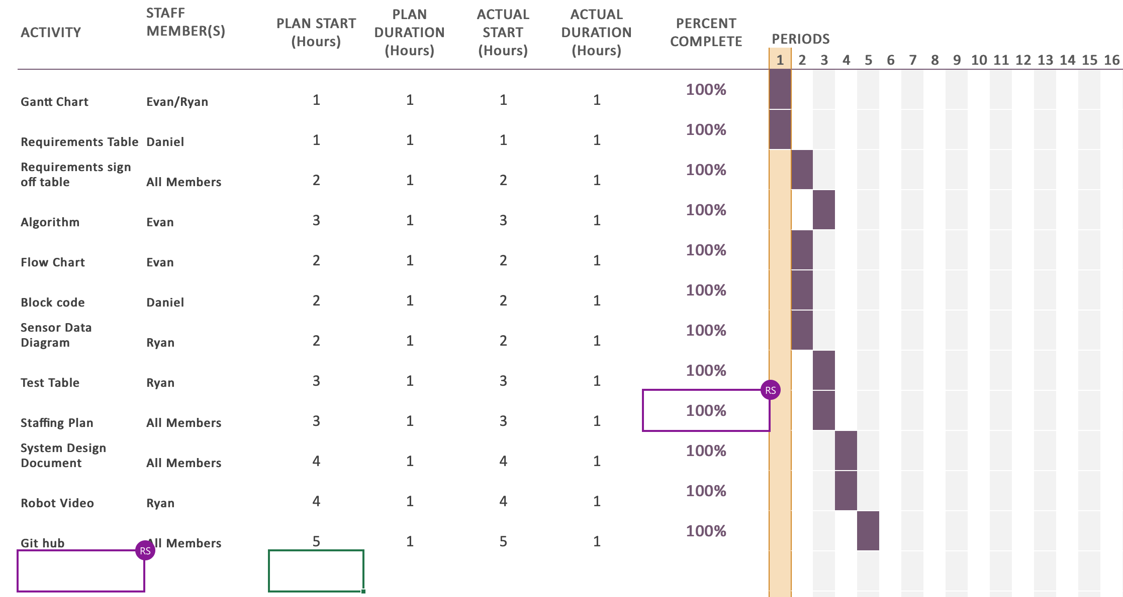

* 1. ***Staffing Plan***

|  |  |  |  |
| --- | --- | --- | --- |
| Name | Role | Responsibility | Reports To |
| Daniel | Group member | Coder/Scribe | N/A |
| Ryan | Handler of the Robot (testing) | Testing/Scribe | N/A |
| Evan | Group member | Organizer/Design/Scribe | N/A |